ETEC 326 – Milestone 1: Detailed Design
Name: Andy Toro (301347177) – Abdurrahman Ghafoor (301110091)
Smart Automatic Trash Bin
Milestone 1: Schematic Capture & Software Coding
1. Emerging Project Management Decisions
(Scope, Resources, Scheduling)
Scope Decisions:
The scope for Milestone 1 is limited to the preliminary detailed design of the smart automatic trash bin. This includes schematic capture, pin assignments, and initial software logic. Physical testing, calibration, and performance optimization are intentionally excluded and deferred to later milestones.
Resource Decisions:
The project uses open-source, low-cost components only:
- Arduino UNO R3
- HC-SR04 ultrasonic sensor
- SG90 servo motor
No proprietary hardware or paid software tools are required.
Scheduling Decisions:
Design activities (hardware schematic + software coding) were prioritized early to reduce integration risk later. Blocking delays and simplified logic were accepted at this stage to meet the milestone deadline.
2. Enabling Technologies
Arduino UNO R3
Acts as the main control unit. It processes distance data from the ultrasonic sensor and outputs a PWM control signal to the servo motor.
HC-SR04 Ultrasonic Sensor
Provides non-contact distance measurement using ultrasonic pulse-echo timing. This enables hygienic, touchless operation.
SG90 Servo Motor
Converts PWM signals into mechanical rotation to open and close the trash bin lid.
Arduino IDE & Libraries
- Servo.h for PWM motor control
- Ultrasonic.h for simplified distance measurement
The Arduino platform supports rapid prototyping and easy future expansion.
Battery-Powered Operation
A 9V supply powers the system through the Arduino VIN/RAW input. Common ground is maintained across all components.
3. Preliminary Detailed Design
3.1 Hardware Design
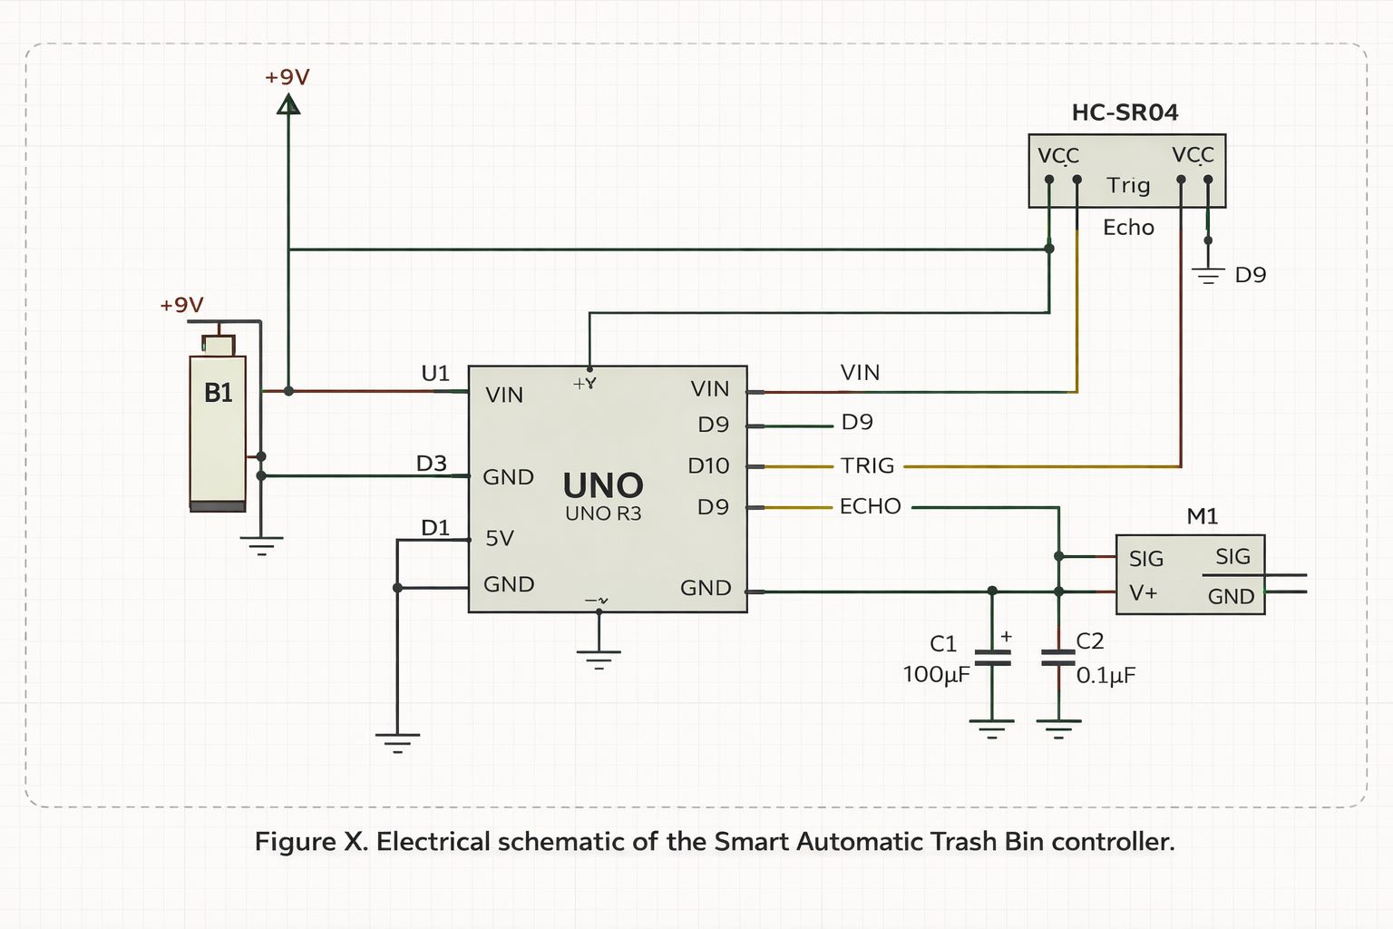

Core Connections:
- HC-SR04
  - VCC → +5V
  - GND → GND
  - TRIG → Arduino D5
  - ECHO → Arduino D8
- SG90 Servo
  - Signal → Arduino D10 (PWM)
  - VCC → +5V (external supply recommended in later stages)
  - GND → Common ground
- Power
  - 9V battery → Arduino VIN/RAW
  - Power switch and reverse-polarity diode included in schematic
Design Notes:
- Single Arduino only (no secondary controllers)
- Schematic-style representation used instead of pictorial wiring
- Servo power isolation recommended for future revision
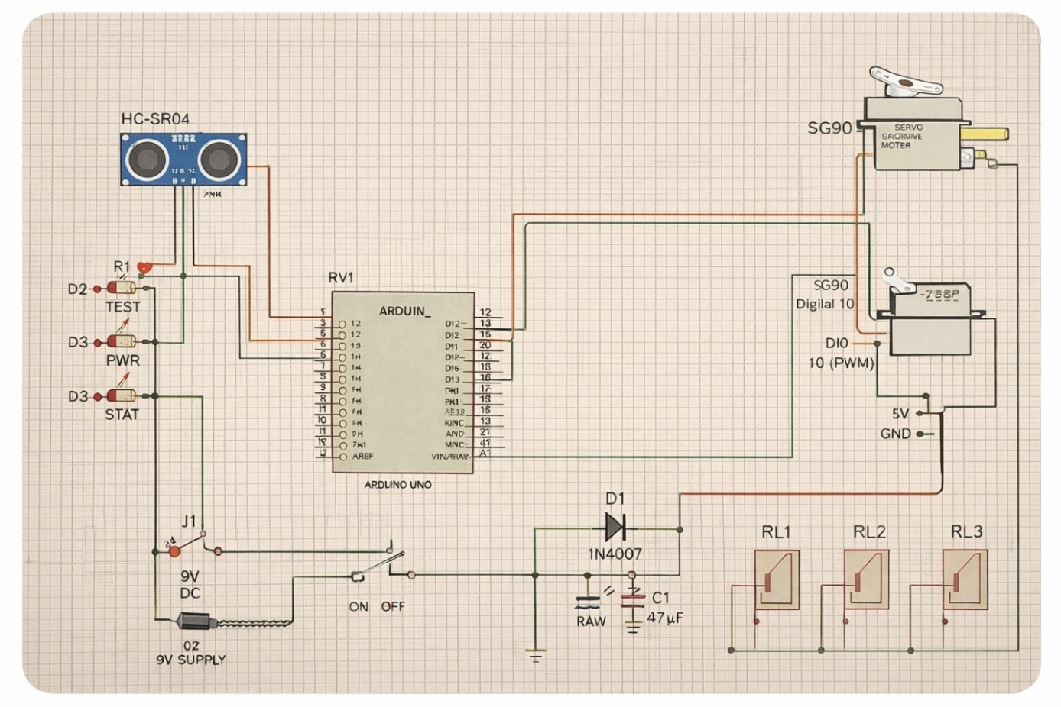
Note: This schematic is preliminary and has not yet been electrically validated.

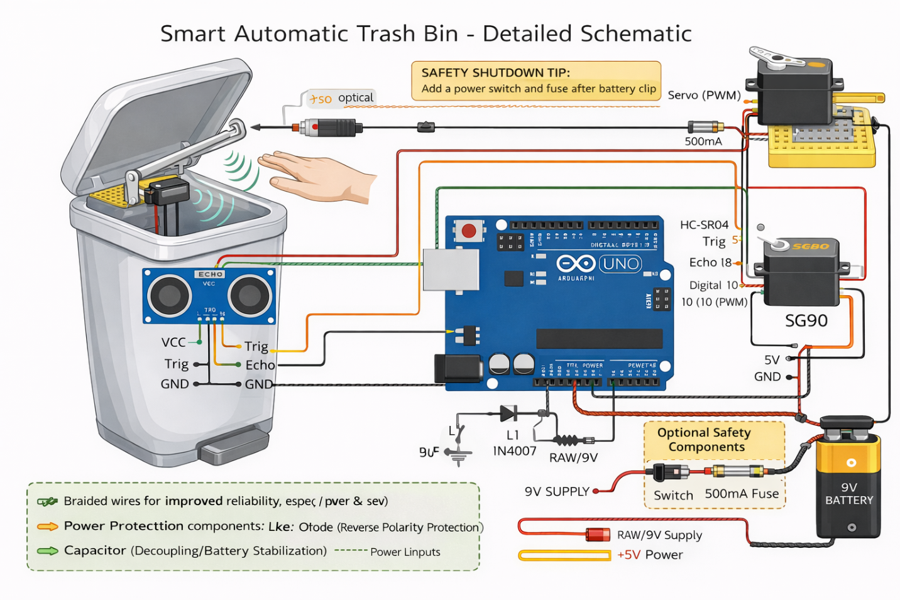
3.2 Software Design
Functional Behavior:
- Continuously measure distance using HC-SR04
- If an object is detected within 30 cm:
  - Open lid
  - Hold open for a fixed time
  - Close lid automatically
Arduino Code:
/*
Smart Automatic Trash Bin - Preliminary (Untested) Code
Course: ETEC326 - Milestone 1 Detailed Design (SW coding)
Components: Arduino UNO + HC-SR04 + SG90 Servo

Pins (default):
HC-SR04 Trig -> D5
HC-SR04 Echo -> D8
SG90 Signal -> D10 (PWM)
All grounds common

Behavior:
- Measures distance continuously
- If distance <= thresholdCm, lid opens
- Lid stays open while object remains close (with small refresh)
- When object leaves, waits closeDelayMs then closes lid
*/

#include <Servo.h>

// ------------------ Pin Definitions ------------------
const int TRIG_PIN = 5;
const int ECHO_PIN = 8;
const int SERVO_PIN = 10;

// ------------------ Tunable Parameters ------------------
const int thresholdCm = 20; // detection distance (cm)
const int openAngle = 90; // servo angle for lid open (adjust to your mechanism)
const int closedAngle = 0; // servo angle for lid closed
const unsigned long closeDelayMs = 1200; // wait before closing after object leaves (ms)

const unsigned long sampleIntervalMs = 80; // sensor sample interval
const int minValidCm = 2; // filter out invalid readings
const int maxValidCm = 200;

// ------------------ Internal State ------------------
Servo lidServo;
bool lidIsOpen = false;
unsigned long lastSampleTime = 0;
unsigned long lastSeenTime = 0;

// ------------------ Function: Read Distance (cm) ------------------
int readDistanceCm() {
// Trigger pulse
digitalWrite(TRIG_PIN, LOW);
delayMicroseconds(2);
digitalWrite(TRIG_PIN, HIGH);
delayMicroseconds(10);
digitalWrite(TRIG_PIN, LOW);

// Read echo duration (timeout prevents freezing)
unsigned long duration = pulseIn(ECHO_PIN, HIGH, 30000UL); // 30 ms timeout (~5m max)

if (duration == 0) return -1; // no echo / out of range

// Convert to cm: speed of sound ~343 m/s
// distance(cm) = duration(us) * 0.0343 / 2
int cm = (int)(duration * 0.0343 / 2.0);

if (cm < minValidCm || cm > maxValidCm) return -1;
return cm;
}

// ------------------ Setup ------------------
void setup() {
pinMode(TRIG_PIN, OUTPUT);
pinMode(ECHO_PIN, INPUT);

lidServo.attach(SERVO_PIN);

// Start closed
lidServo.write(closedAngle);
delay(500);

// Optional: serial monitoring
Serial.begin(9600);
Serial.println("Smart Trash Bin - Preliminary (Untested) Starting...");
}

// ------------------ Loop ------------------
void loop() {
unsigned long now = millis();

// sample sensor at a steady interval
if (now - lastSampleTime >= sampleIntervalMs) {
lastSampleTime = now;

int d = readDistanceCm();

// Debug
Serial.print("Distance (cm): ");
Serial.println(d);

// If we detect an object within threshold, mark "seen"
if (d > 0 && d <= thresholdCm) {
lastSeenTime = now;

// open if not already open
if (!lidIsOpen) {
lidServo.write(openAngle);
lidIsOpen = true;
Serial.println("LID: OPEN");
}
}

// If lid open and we have NOT seen object for closeDelayMs, close it
if (lidIsOpen && (now - lastSeenTime >= closeDelayMs)) {
lidServo.write(closedAngle);
lidIsOpen = false;
Serial.println("LID: CLOSED");
}
}
}
Simplified code:
#include <Ultrasonic.h>
#include <Servo.h>

/*
Smart Automatic Trash Bin
Preliminary / Untested Software
ETEC 326 – Milestone 1
*/

Servo myservo;
Ultrasonic ultrasonic(5, 8); // Trig = D5, Echo = D8

int distance;

void setup() {
myservo.attach(10); // Servo signal on D10 (PWM)
Serial.begin(9600);
myservo.write(0); // Lid closed initially
}

void loop() {
distance = ultrasonic.read(); // distance in cm

if (distance > 0 && distance <= 30) {
myservo.write(60); // Open lid
delay(4000); // Hold open (blocking – preliminary design)
myservo.write(0); // Close lid
}

Serial.print("Distance (cm): ");
Serial.println(distance);
delay(100);
}

Software Design Limitations:
- Uses blocking delay (delay ())
- No noise filtering or averaging
- No power optimization
(All to be addressed in later milestones)
4. Discarded Designs / Features and Rationale
- LCD Display
Removed to reduce complexity, cost, and power consumption.
- Infrared Sensors
Discarded due to sensitivity to ambient light and reflective surfaces.
- Dual-Arduino Architecture
Rejected as unnecessary; single Arduino is sufficient for all functions.
- IoT / Wi-Fi Connectivity
Deferred to avoid scope creep and ensure milestone completion.

